Kubernetes Cluster on Ubuntu VMs

Installation Guide

Installation Guide for Kubernetes

Installation Guide

**Note:** For this installation we recommend a fresh ubuntu image since Kubernetes cantake up a lot of resources.

Following are the preferable VM settings:

Master:

* 2GB RAM
* 2 Cores of CPU

Slave Node:

* 1 GB RAM
* 1 Core of CPU

Step 1:

1. Open your Virtual Box Manager, and create new VMs

© B r a i n 4 c e E d u c a t i o n S o l u t i o n s P v t . L t d Page 1

Installation Guide for Kubernetes

r a i n 4 c e E d u c a t i o n S o l u t i o n s P v t . L t d Pa

Installation Guide for Kubernetes

Step 3: Right Click on your VM, and click on Settings.

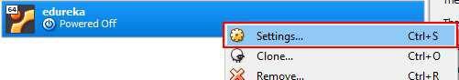

Step 4: Edit the name as kmaster, and click on OK

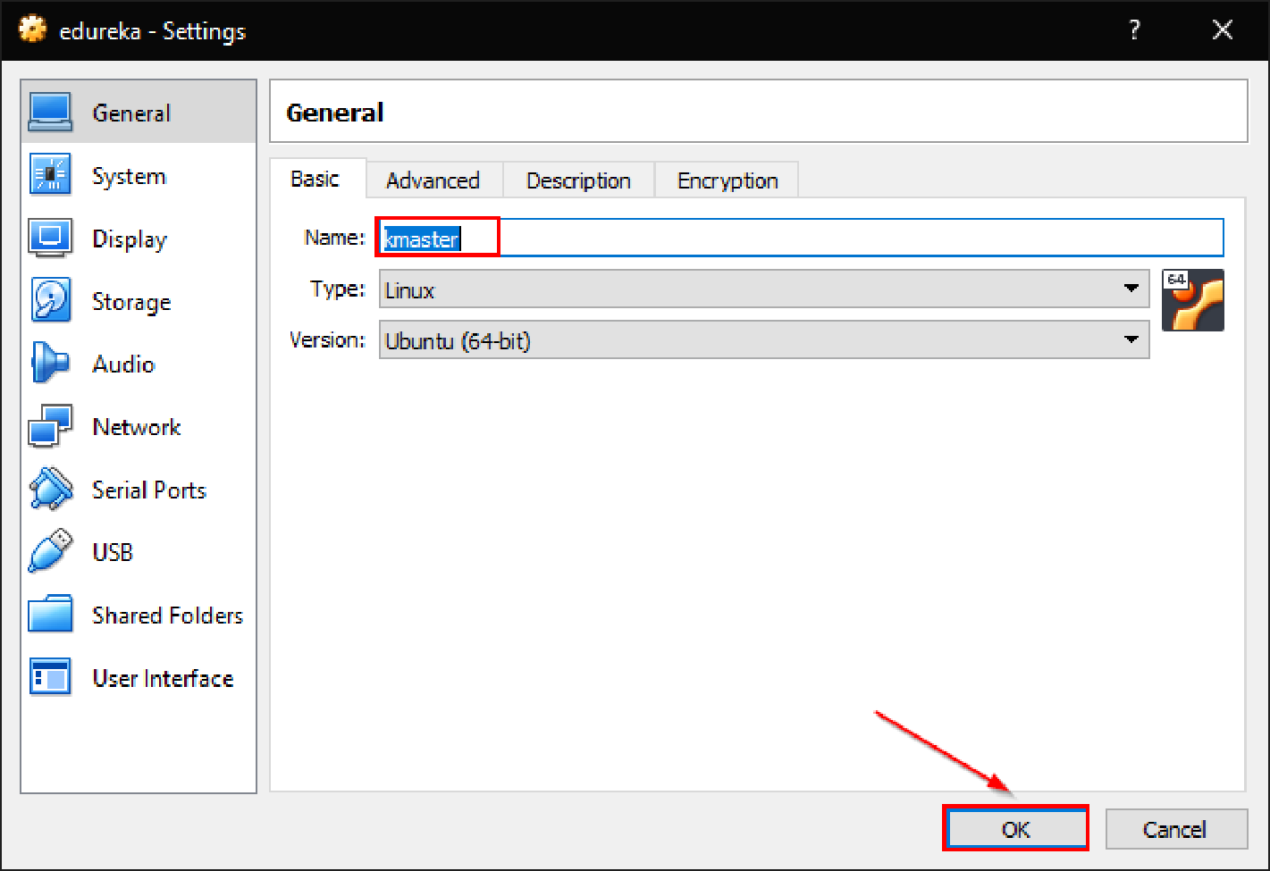

Step 5: Repeat the same steps to get a Slave Node, and name it as “knode”.

© B r a i n 4 c e E d u c a t i o n S o l u t i o n s P v t . L t d Page 3

Installation Guide for Kubernetes

**Steps for Master and Slave VMs**

**Note:** These steps are common to both kmaster and knode VMs

Step 1:

1. Run the following commands:

sudo su

apt-get update

swapoff -a

nano /etc/fstab

1. Add a “#” in front of the last line, to comment it.

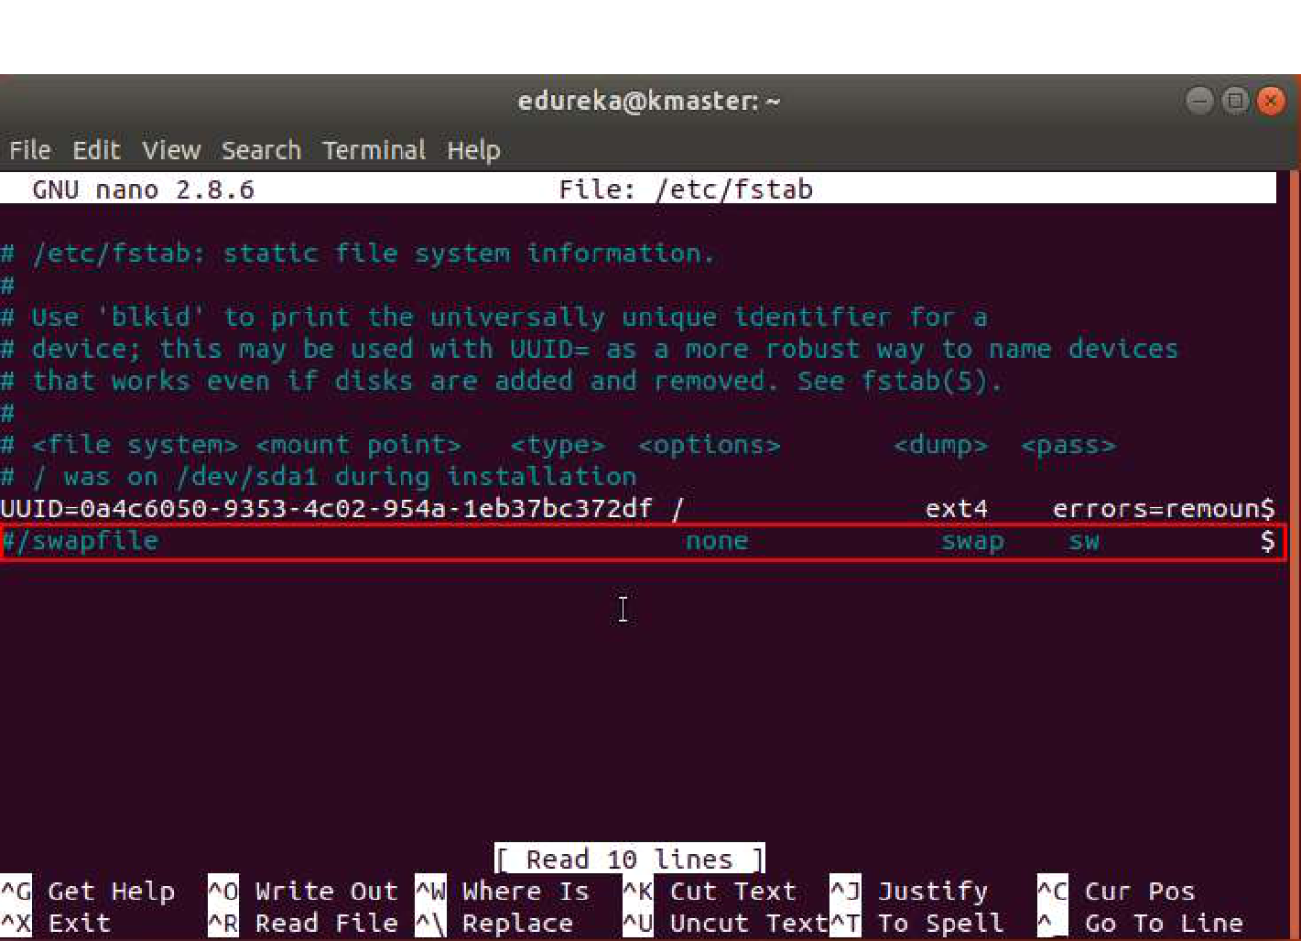

3. Press Ctrl+X, then press Y, and then press Enter to Save.

© B r a i n 4 c e E d u c a t i o n S o l u t i o n s P v t . L t d Page 4

Installation Guide for Kubernetes

Step 2:

1. Run the following command: nano /etc/hostname
2. Edit the name to “kmaster” for kmaster VM, and “knode” for knode VM.

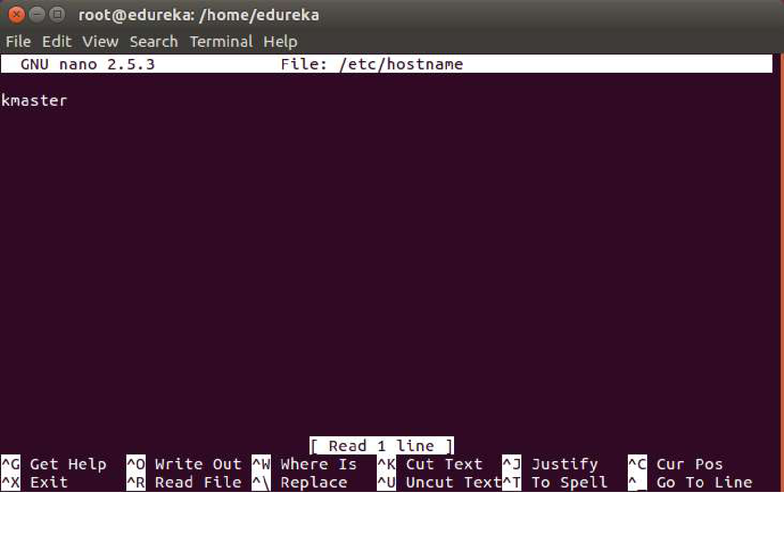

3. Press Ctrl+X, then press Y, and then press Enter to Save.

© B r a i n 4 c e E d u c a t i o n S o l u t i o n s P v t . L t d Page 5

Installation Guide for Kubernetes

Step 3:

1. Run the following command: ifconfig
2. Make a note of the IP address from the output of the above command. The IP address which has to be copied should be under “enp0s8”, as shown in the screenshot below.

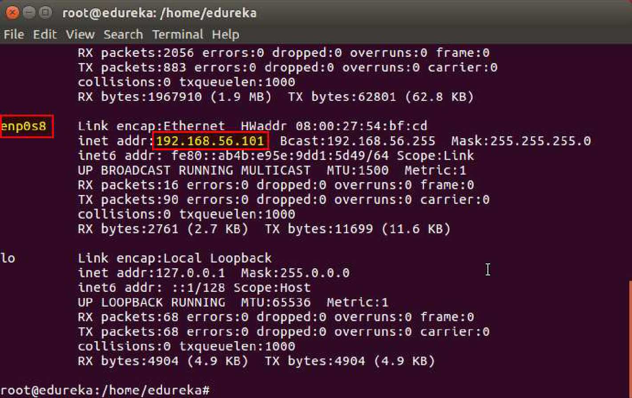

3. Make a note of the IP address of both the VMs using the above commands.

© B r a i n 4 c e E d u c a t i o n S o l u t i o n s P v t . L t d Page 6

Installation Guide for Kubernetes

Step 4:

1. Run the following command: nano /etc/hosts
2. Enter the IP address of the kmaster VM and the knode VM both in this file. (This has to be done in both the VMs). In front of the IP address of master write, “kmaster”. Similarly, in front of the Node IP address write “knode”.

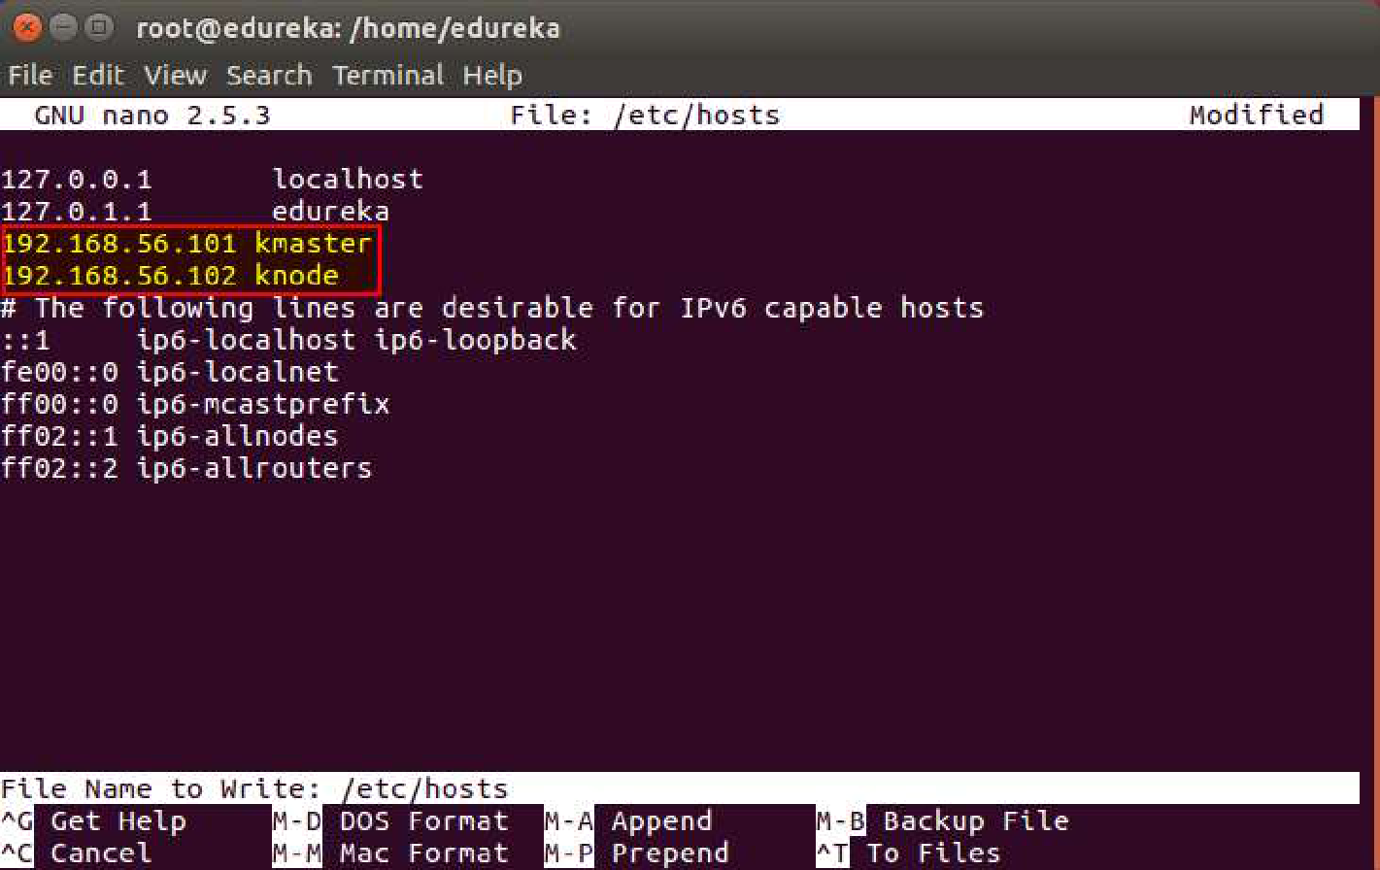

3. Press Ctrl+X, then press Y, and then press Enter to Save.

© B r a i n 4 c e E d u c a t i o n S o l u t i o n s P v t . L t d Page 7

Installation Guide for Kubernetes

Step 5: Next, we will make the IP addresses used above, static for the VMs.

1. Run the following command:

nano /etc/network/interfaces

2. Enter the following in this document:

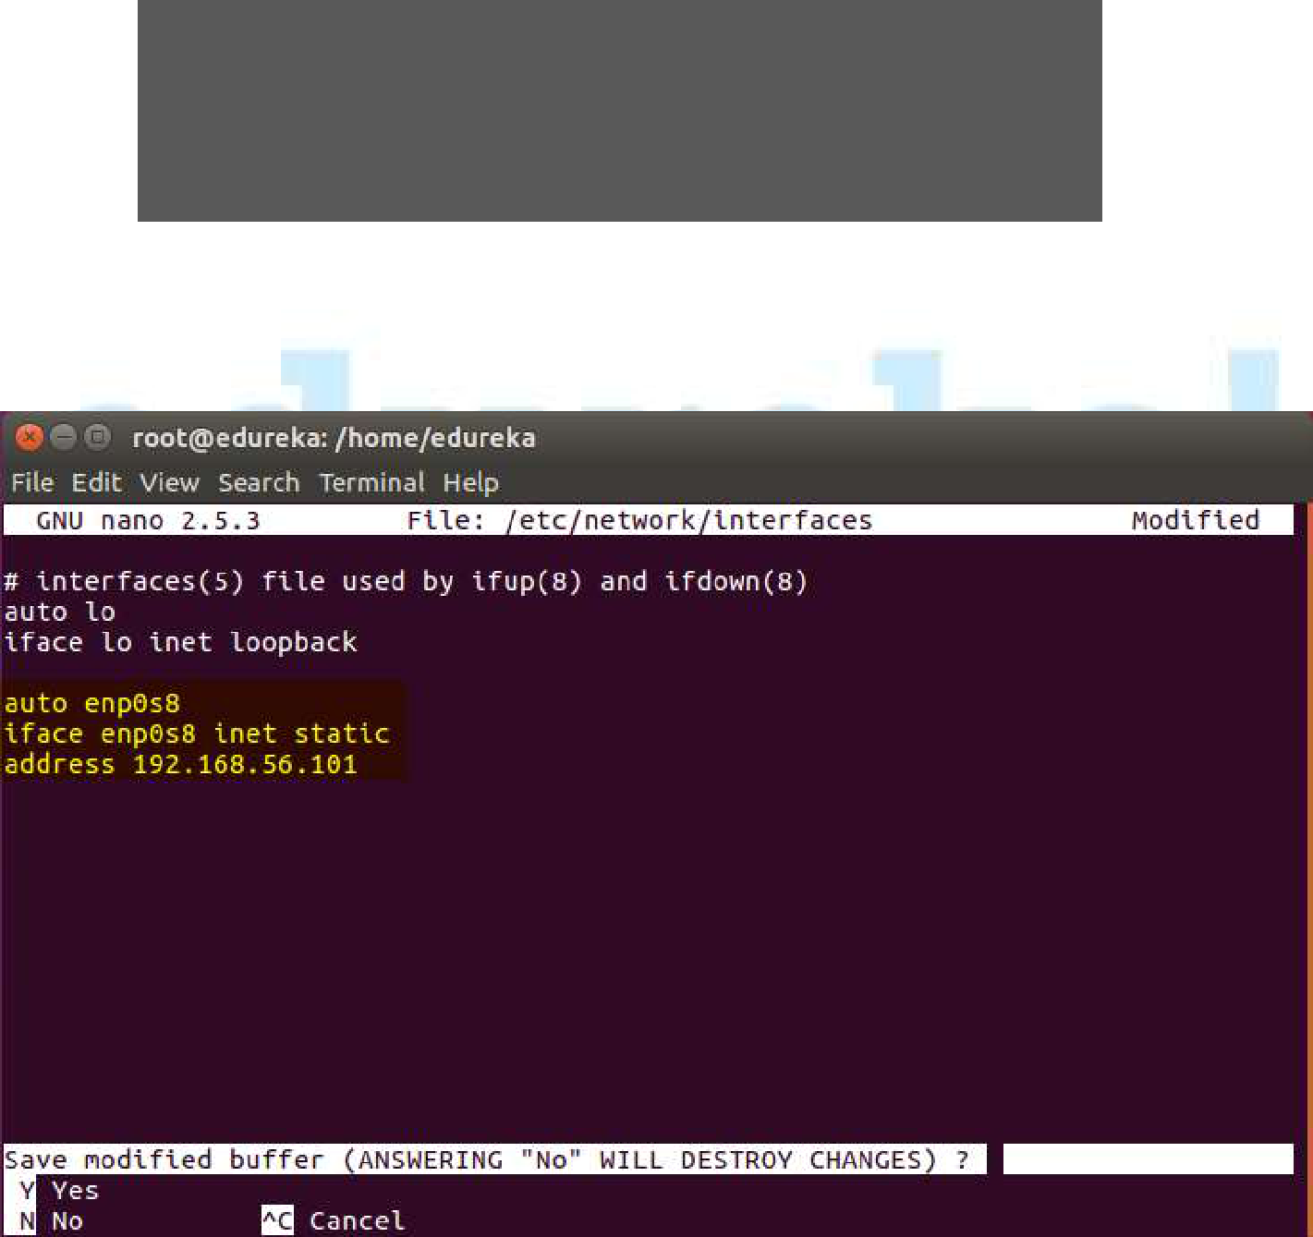

auto enp0s8

iface enp0s8 inet static

address <IP-Address-Of-VM>

3. It will look like the following:

1. Press Ctrl+X, then press Y, and then press Enter to Save.
2. After this, restart your machine.

© B r a i n 4 c e E d u c a t i o n S o l u t i o n s P v t . L t d Page 8

Installation Guide for Kubernetes

Step 6: Now we will install openssh-server. Run the following command:

sudo apt-get install openssh-server

Step 7: Next, we will install Docker. Run the following commands:

sudo su

apt-get update

apt-get install -y docker.io



Step 8: Next, we will install kubeadm, kubelet and kubectl. Run the following commands:

apt-get update && apt-get install -y apt-transport-https curl

curl -s

https://packages.cloud.google.com/apt/doc/apt-

key.gpg | apt-key add -

cat <<EOF >/etc/apt/sources.list.d/kubernetes.list deb http://apt.kubernetes.io/ kubernetes-xenial main EOF

apt-get update

apt-get install -y kubelet kubeadm kubectl

© B r a i n 4 c e E d u c a t i o n S o l u t i o n s P v t . L t d Page 9

Installation Guide for Kubernetes

Step 9:

1. Next, we will change the configuration file of Kubernetes. Run the following command:

nano /etc/systemd/system/kubelet.service.d/10-kubeadm.conf

1. This will open a text editor, enter the following line after the last

“Environment” Variable.

Environment=”cgroup-driver=systemd/cgroup-driver=cgroupfs”

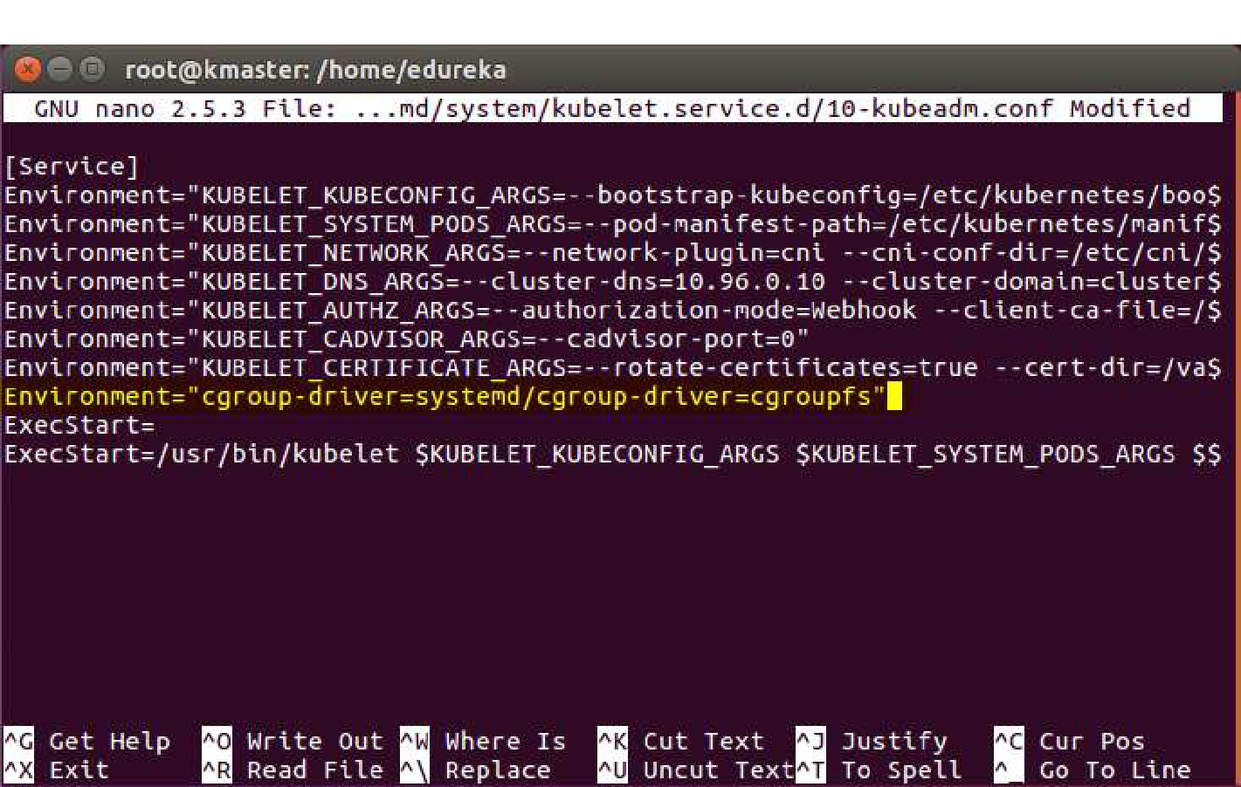

1. Press Ctrl+X, then press Y, and then press Enter to Save. Step 10: Restart your VMs for the changes to take effect.

You have successfully installed Kubernetes on both the machines now!

© B r a i n 4 c e E d u c a t i o n S o l u t i o n s P v t . L t d Page 10

Installation Guide for Kubernetes

© B r a i n 4 c e E d u c a t i o n S o l u t i o n s P v t . L t d Page 11

Installation Guide for Kubernetes

**Steps for only Master VM**

**Note:** These steps will only be executed on the master node (kmaster VM).

Step 1: We will now Initialize our Master VM. For that execute the following command:

kubeadm init --apiserver-advertise-address=<ip-address-of-kmaster-vm> --pod-network-cidr=192.168.0.0/16

1. You will get the below output. The commands marked as (1), execute them as a non-root user. This will enable you to use kubectl from the CLI
2. The command marked as (2) should also be saved for future. This will be used to join nodes to your cluster.

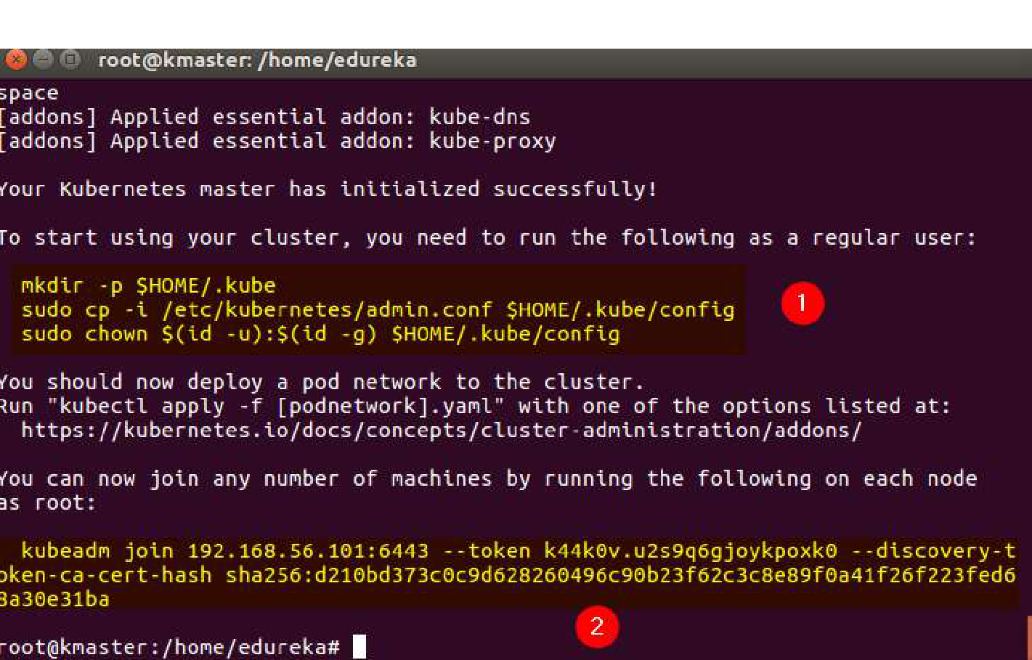

© B r a i n 4 c e E d u c a t i o n S o l u t i o n s P v t . L t d Page 12

Installation Guide for Kubernetes

Step 2:

1. Like mentioned before, run the commands from the above output as a non-root user.

mkdir -p $HOME/.kube

sudo cp -i /etc/kubernetes/admin.conf $HOME/.kube/config

sudo chown $(id -u):$(id -g) $HOME/.kube/config

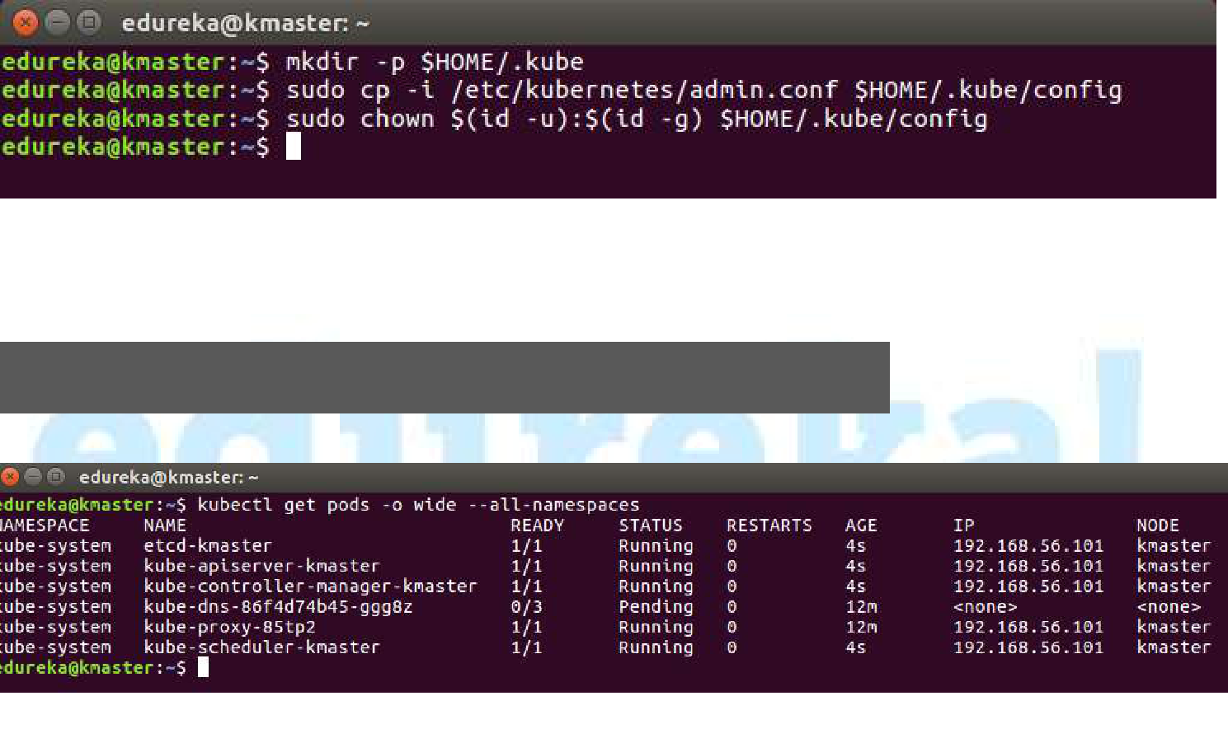

2. To verify, if kubectl is working or not, run the following command:

kubectl get pods -o wide --all-namespaces

© B r a i n 4 c e E d u c a t i o n S o l u t i o n s P v t . L t d Page 13

Installation Guide for Kubernetes

Step 3:

1. You will notice from the previous command, all the pods are running except one, kube-dns. For resolving this we will install a pod network. To install the pod network, run the following command:

kubectl apply -f

https://docs.projectcalico.org/v3.0/getting-

started/kubernetes/installation/hosted/kubeadm/1.7/calico.

yaml

2. After some time, you will notice that all pods shift to the running state.

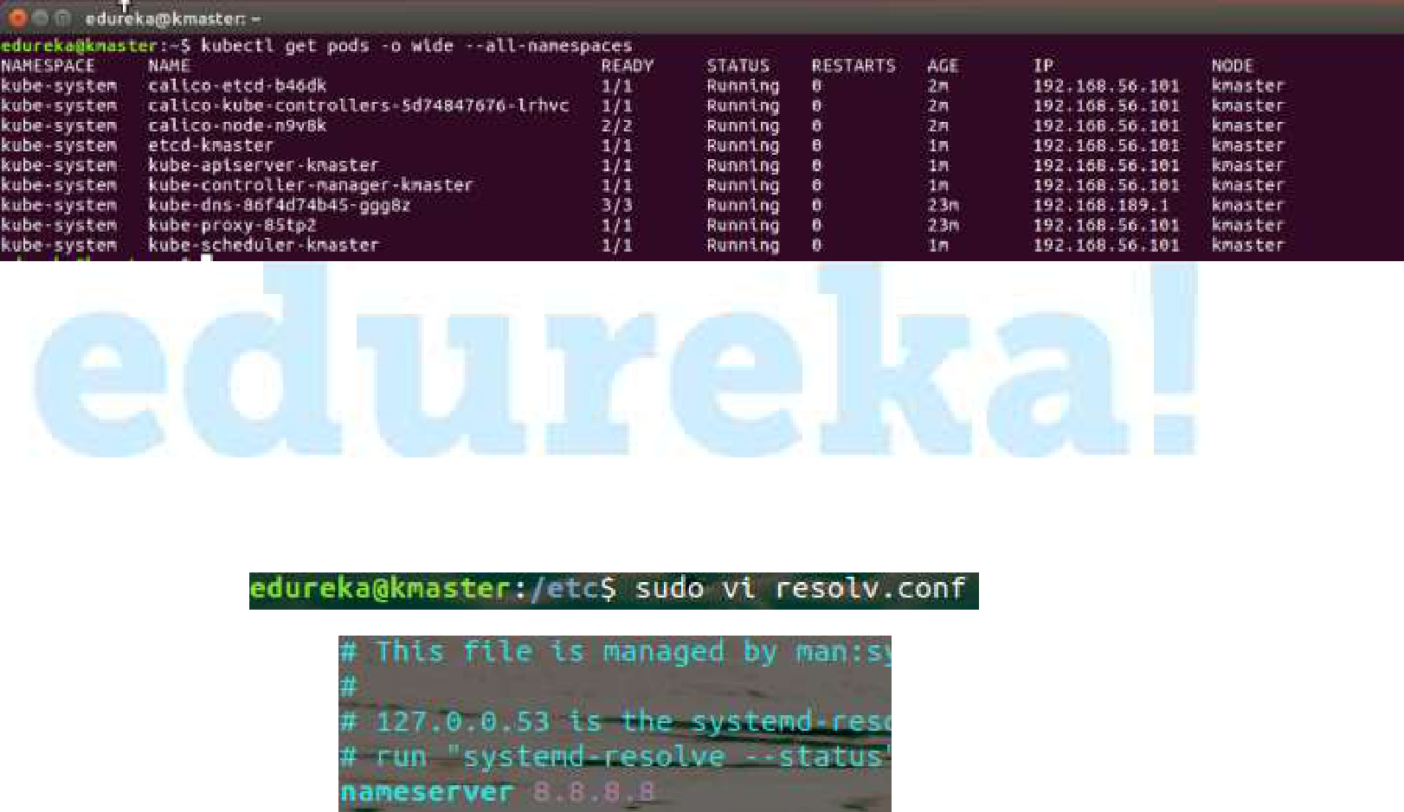

Troubleshooting:

If the internet stops working after installing the pod network or you get an image pull back error in pods, edit the **resolv.conf** file inside the **/etc** directory and change the nameserver to **8.8.8.8**

Syntax: sudo vi /etc/reslov.conf

The internet should work fine now.

Step 4: Next, we will install the dashboard. To install the Dashboard, run the following command:

kubectl create -f

https://raw.githubusercontent.com/kubernetes/dashboard/mas

ter/src/deploy/recommended/kubernetes-dashboard.yaml

© B r a i n 4 c e E d u c a t i o n S o l u t i o n s P v t . L t d Page 14

Installation Guide for Kubernetes

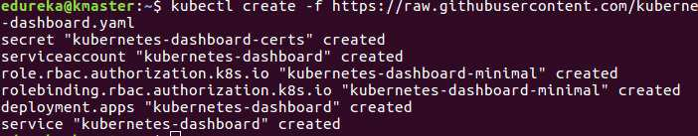

Step 5: Your dashboard is now ready with it’s the pod in the running state.

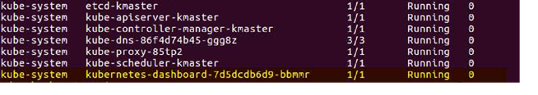

Step 6:

1. By default dashboard will not be visible on the Master VM. Run the following command in the command line:

Kubectl proxy

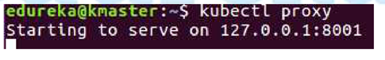

1. To view the dashboard in the browser, navigate to the following address in the browser of your Master VM.

http://localhost:8001/api/v1/namespaces/kube-system/services/https:kubernetes-dashboard:/proxy/

© B r a i n 4 c e E d u c a t i o n S o l u t i o n s P v t . L t d Page 15

Installation Guide for Kubernetes

3. You will prompted with this page, to enter the credentials.

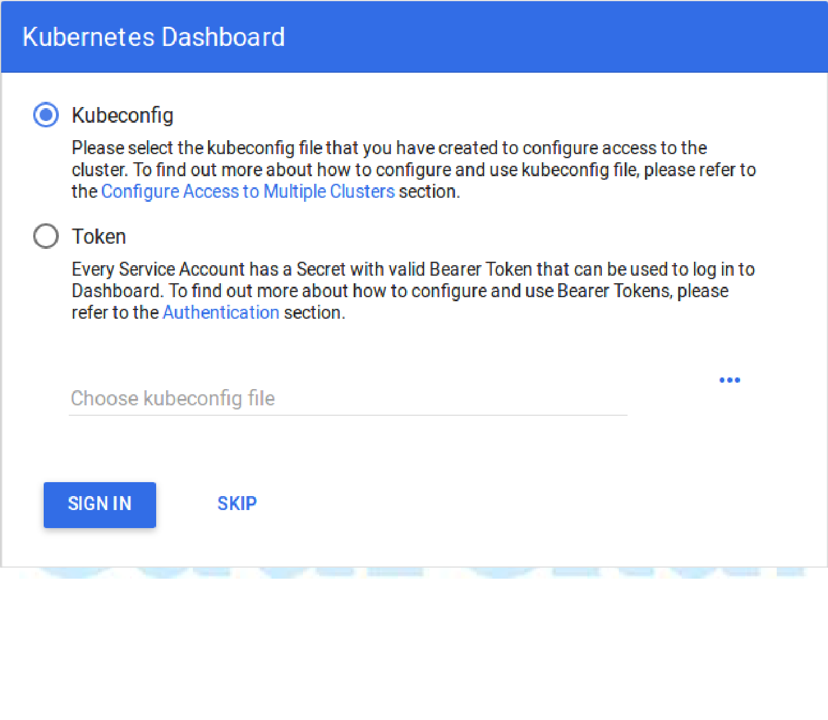

Step 7: In this step, we will create the service account for the dashboard and get it’s credentials. Run the following commands:

**Note:** Run all these commands in a new terminal, or your kubectl proxy commandwill stop.

1. This command will create service account for dashboard in the default namespace.

kubectl create serviceaccount dashboard -n default

2. This command will add the cluster binding rules to your dashboard account

kubectl create clusterrolebinding dashboard-admin -n default \

--clusterrole=cluster-admin \

--serviceaccount=default:dashboard

© B r a i n 4 c e E d u c a t i o n S o l u t i o n s P v t . L t d Page 16

Installation Guide for Kubernetes

3. This command will give you the token required for your dashboard login.

kubectl get secret $(kubectl get serviceaccount dashboard -

1. jsonpath="{.secrets[0].name}") -o jsonpath="{.data.token}" | base64 --decode

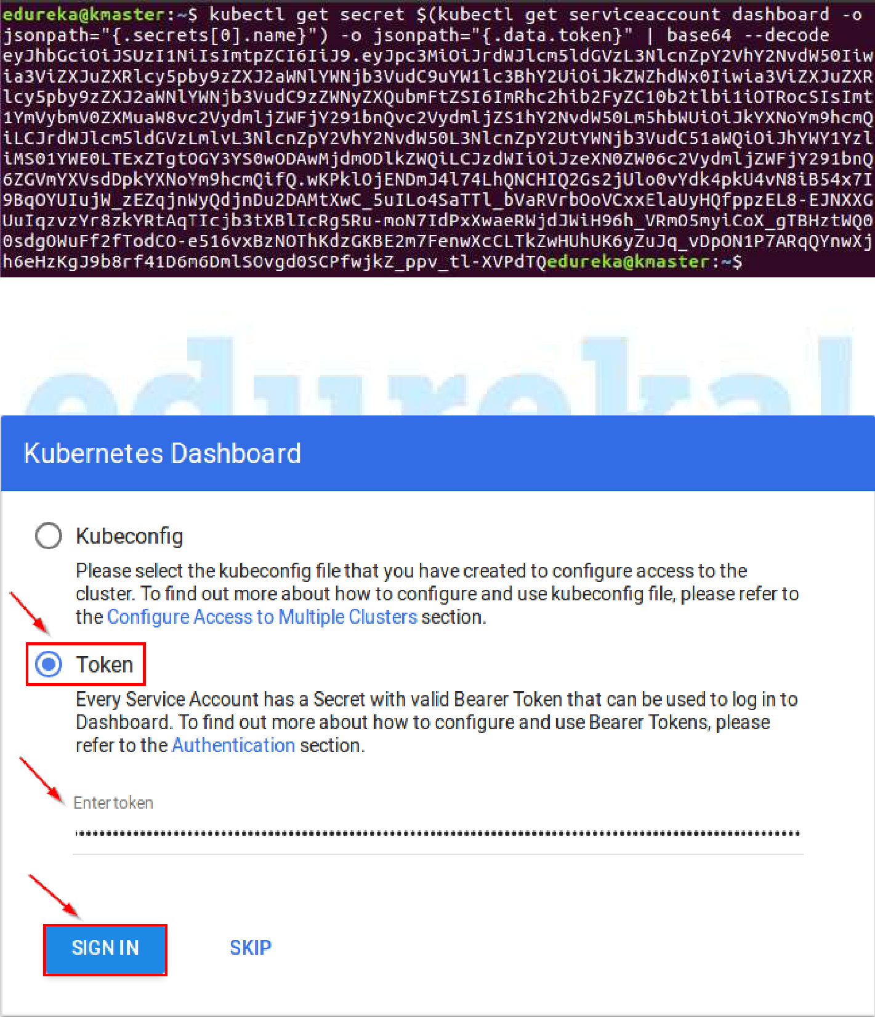

1. Copy this token and paste it in Dashboard Login Page, by selecting token option.

© B r a i n 4 c e E d u c a t i o n S o l u t i o n s P v t . L t d Page 17

Installation Guide for Kubernetes

5. You have successfully logged in your dashboard!

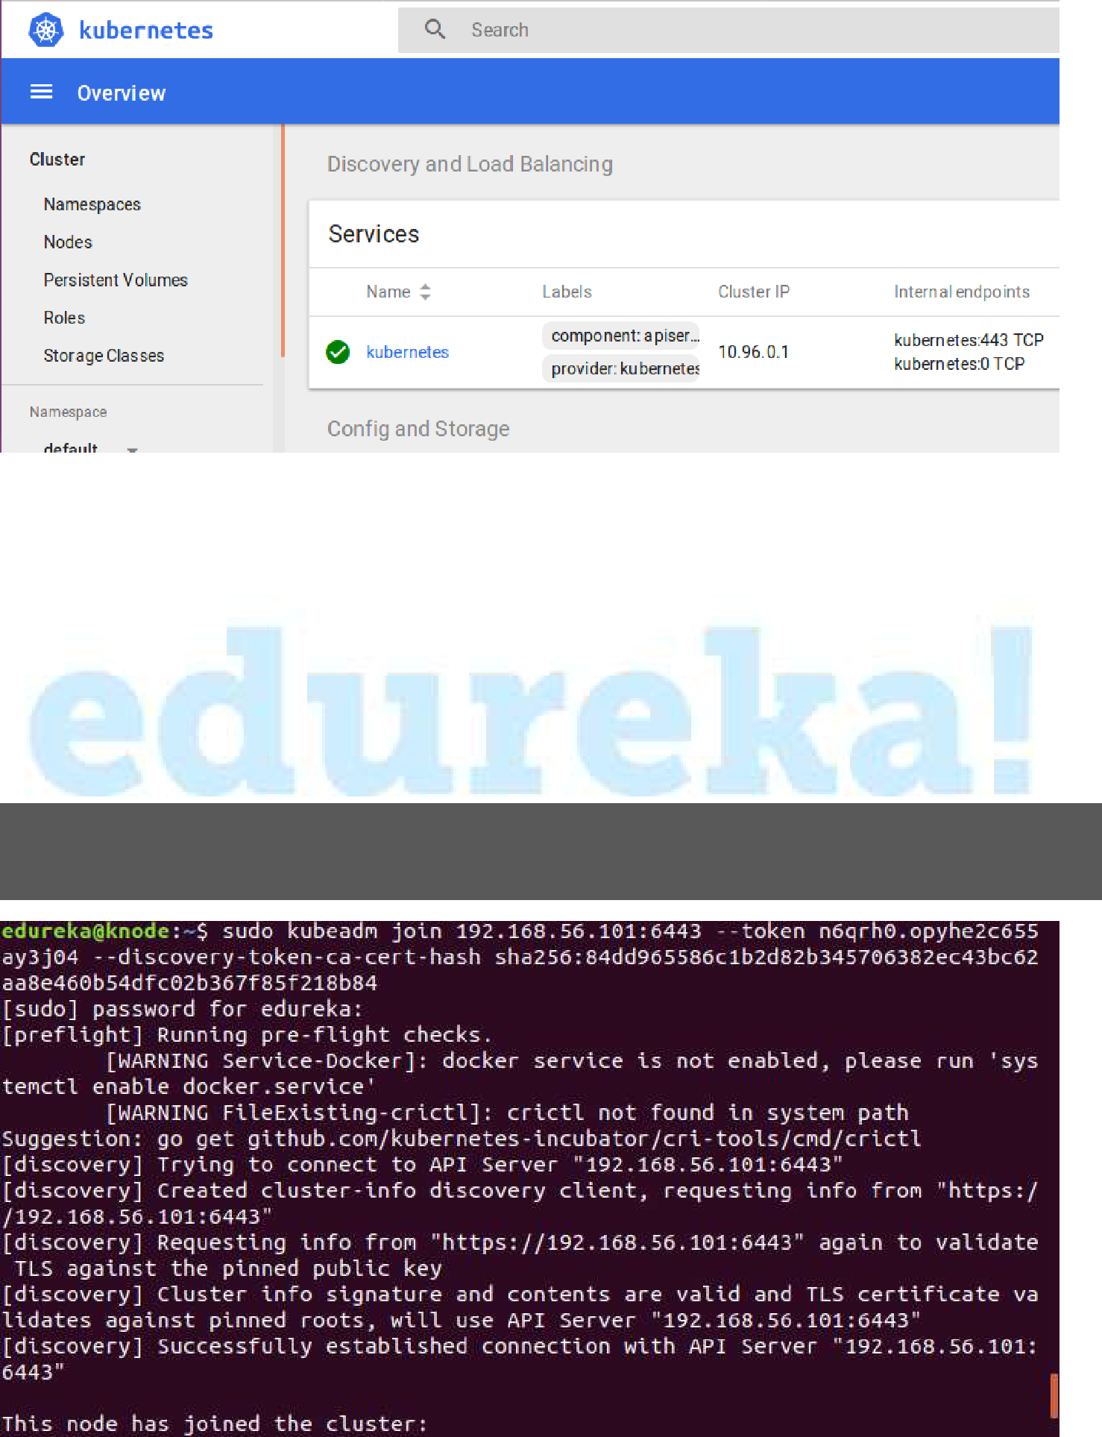

**Steps for only Node VM**

**Step 1:** It is time to join your node to the cluster! This is probably the only step thatyou will be doing on the node, after installing kubernetes on it. Run the join command that you saved, when you ran kubeadm init command on the master. **Note:** Run this command with “sudo”.

sudo kubeadm join --apiserver-advertise-address=<ip-address-of-the master> --pod-network-cidr=192.168.0.0/16

**Your Kubernetes Cluster is ready! :-)**

© B r a i n 4 c e E d u c a t i o n S o l u t i o n s P v t . L t d Page 18